TRUNK or TREAT
Please join the Living Savior Youth Group for Trunk or Treat! We welcome the preschool families! Saturday, Oct. 30th from 2 to 5 PM. Children’s costume parade at 3 PM.

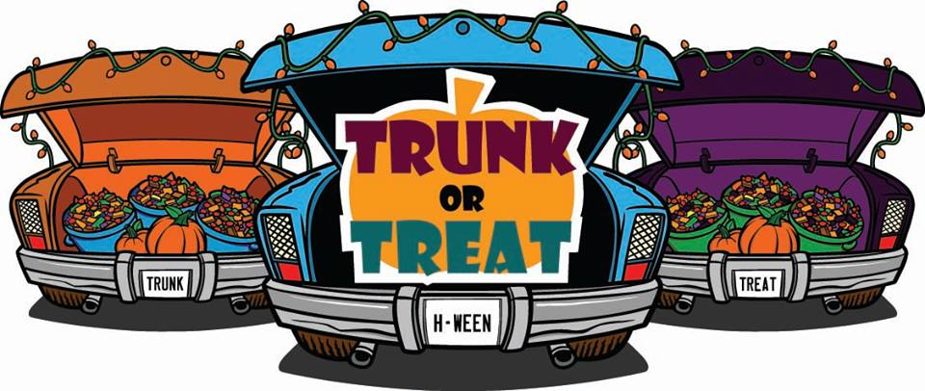
This is an LSLC youth sponsored event for the community. It is FREE.
To display a vehicle, please RSVP to Jonathan Loesch @ 571-641-7249 or Jonathan.loesch@fairfaxcounty.gov for more info. All are welcome!
The FCPD will display a cruiser and provide FREE car seat inspections. (The car seat inspections are subject to cancellation)
Please arrive by 1:30 to set up your vehicle and display. Last year was great, let’s make this year’s event bigger and better!
We plan to have mini-tractor-wagon/hay rides and a bonfire with smores. TRUNK or TREAT

